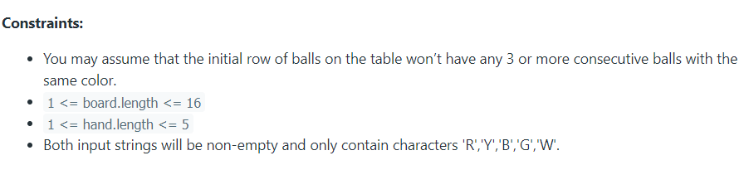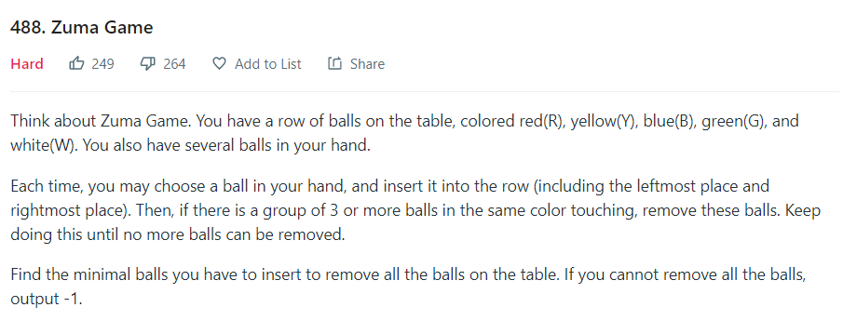Algorithm Challenge Hard Problem: problem, input, output, constraints

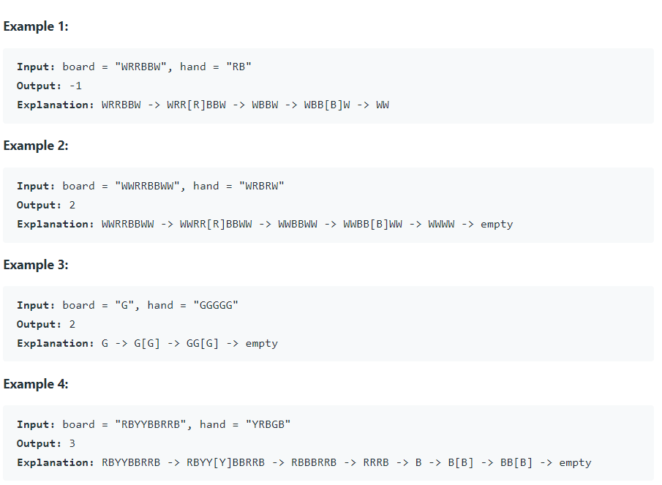

Finish the code in Hard Problem:

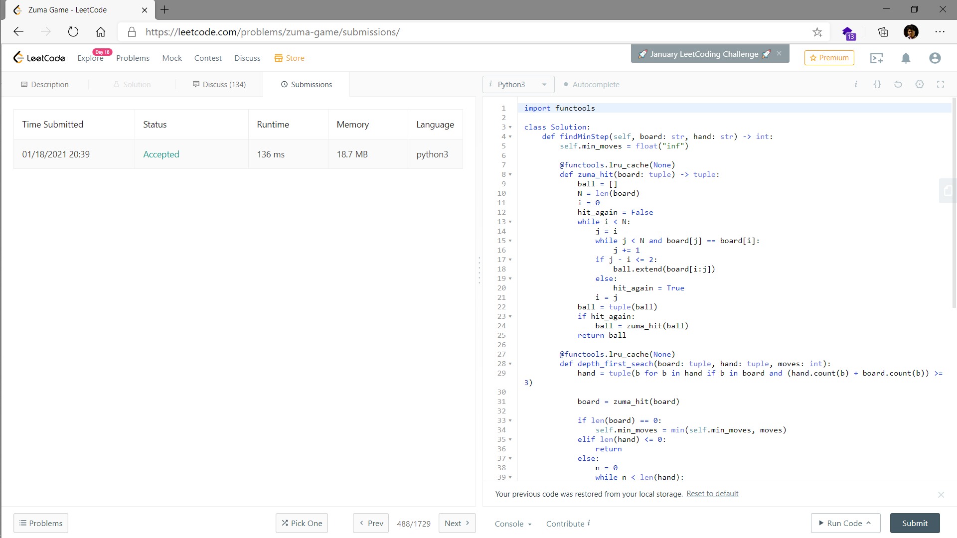Time complexity: n3 Space complexity: n

Pseudo code

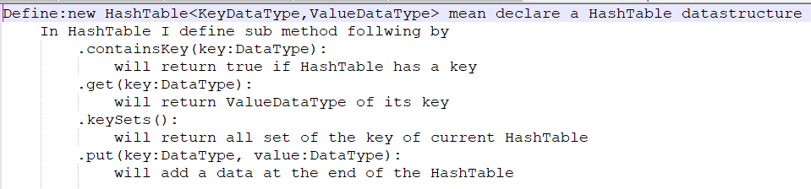Define: hashTable

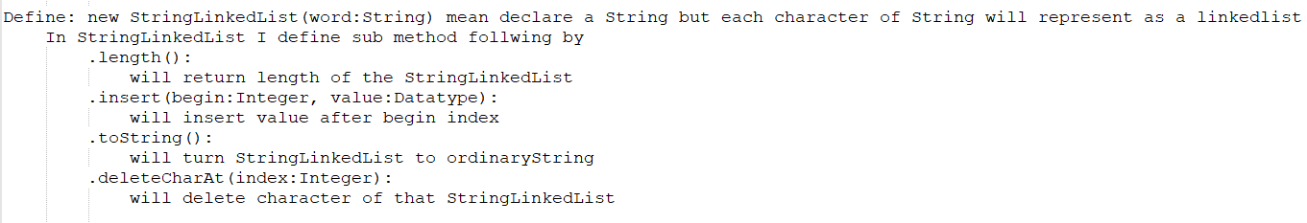Define StringLinkedList

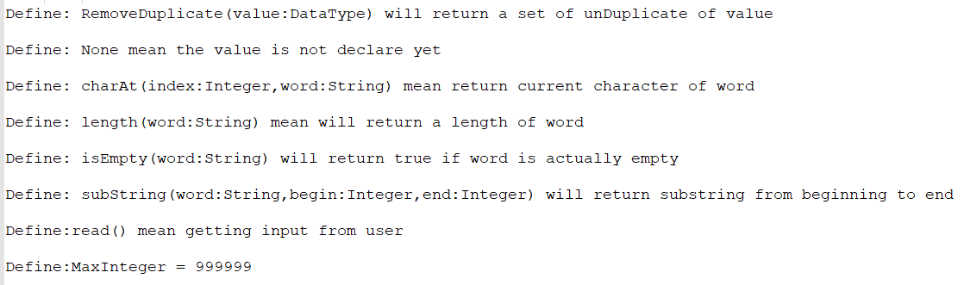Define Basic Element

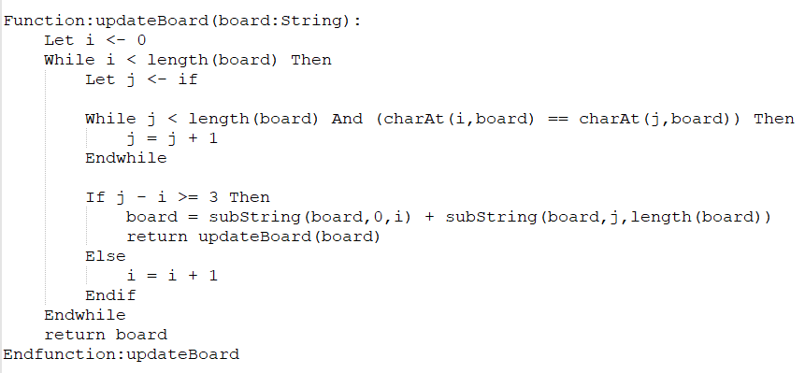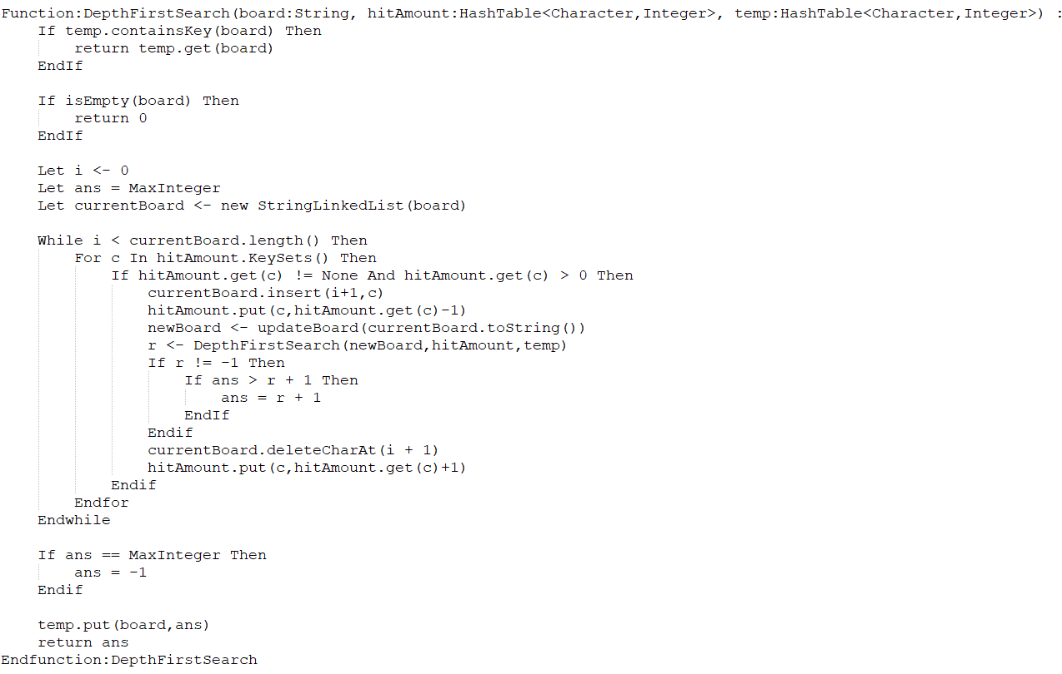

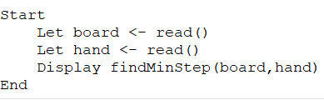

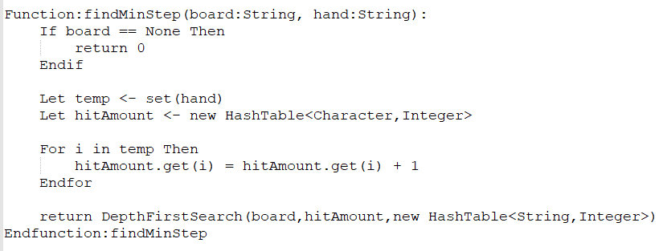

This algorithm will work like this

1. It will search though the line of ball if it detects that they have the same color more than 3 balls it will remove that line and then count the ball by 1
2. Do it again and again util ball in the board or ball in the hand are runs out.
3. Other way to end this program is it shoot the ball though the line of ball and if the ball not run out it will return -1
4. But there so many pattern in the line of ball So it will back to do it again util it reach a small hit of ball

Show that algorithm are correct

"RRWWRRBBRR", "WB".

RRWWRRBBRR -> RRWWRRBBR[W]R -> RRWWRRBB[B]RWR -> RRWWRRRWR -> RRWWWR -> RRR -> empty

My code

Setup environment

Text editor: visual studio code + java extension

Programming language: java SE 11

